From Front view | Depth /mm | Width/mm
Living Room | 1500 | 516 + 1009 + 516
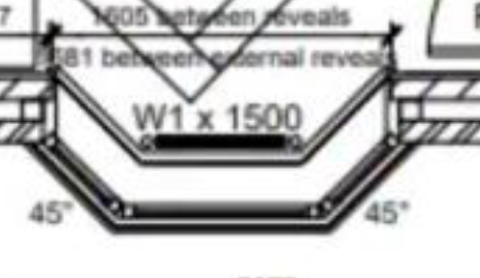

Front Bedroom 1st floor | 1200 | 915
Upstairs Landing 1st floor | 1200 | 915
Top Bedroom
- Front | 1050 | 915

Rear View | Depth /mm | Width/mm
Skylight 1 – blinds | 1400 | 780
Skylight 2 – blinds | 1400 | 780
2nd floor bathroom – blinds | 980 | 780
1st floor bathroom – blind needed | 1200 | 915
Rear Bedroom 1st floor | 1200 | 915
Rear patio door | 2100 | 1500
Kitchen window | 1200 | 915
Side View | Depth /mm | Width/mm
Living room window | 1200 | 915

