DIRECTIONS TO THE PARKS DIVISION - WARDOWN PARK
Parks Division, Luton Borough Council, Wardown Park Offices, Old Bedford Road, Luton LU2 7HA
Access to our offices is generally from the New Bedford Road side of Wardown Park: _ _ _but if you are just collecting keys, it maybe more convenient to use the Old Bedford Road driveway.
4
You need to walk across from the car park with the Museum on your right, then pass under the brick arch. In the corner of the courtyard adjacent to the arch is a black gate built into the wall – please press the intercom buzzer and we will let you through. You then walk through the alleyway and the porta-cabin building is ahead of you. Please enter through the door at the top of the ramp.
The Central Car Park off Old Bedford Road by the bowling green is also available should the other car park be full: _ _ _
The driveway by the cricket club is now reserved for staff parking but a quick stop to collect keys is acceptable.
Should you have any difficulties locating us, please call 01582 546700 or 01582 546735
Thank you.
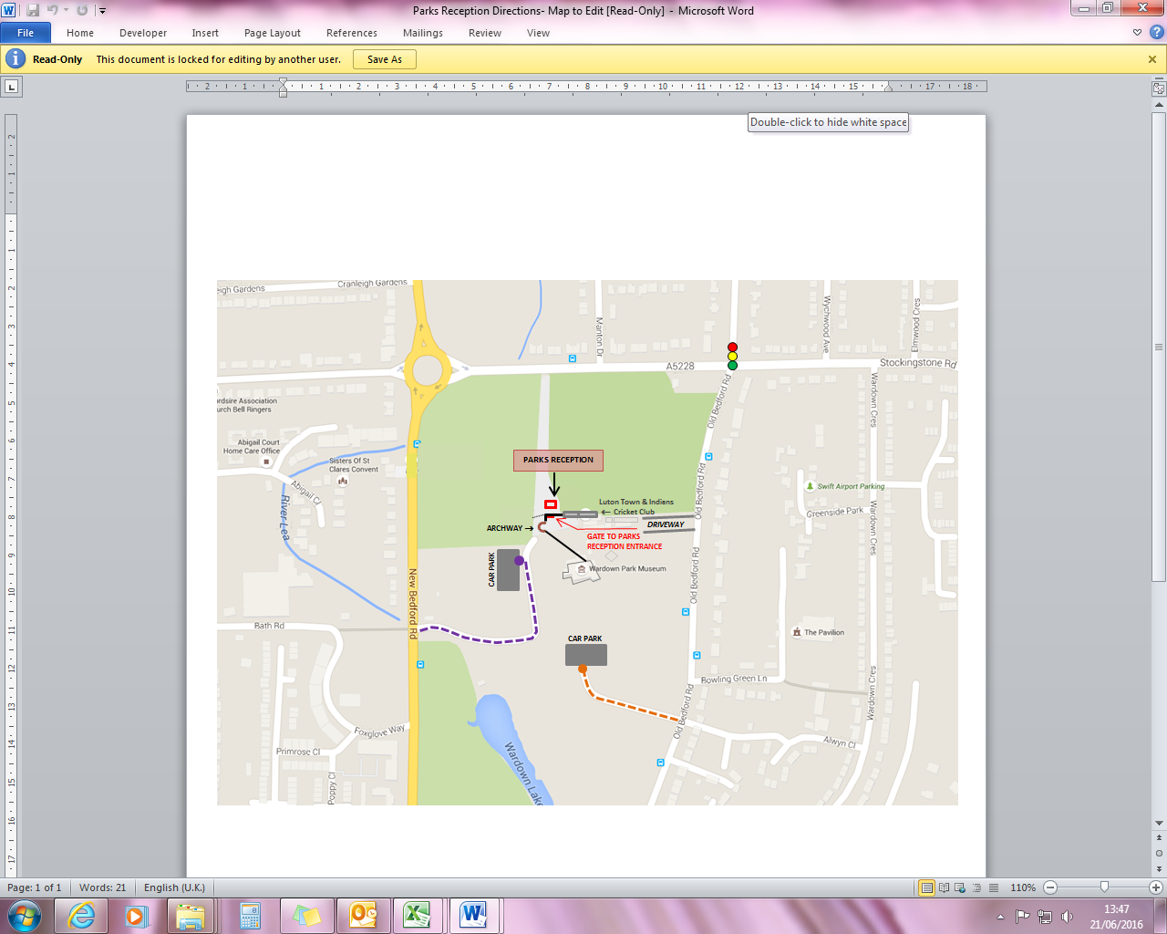
LUTON

