Google Calendar Integration:
- Google calendar integration option will help you to synchronize the BlindMatrix calendar appointments with Google calendar and vice versa.
- Step1: Click on settings Select Application Setup Click on Edit button.
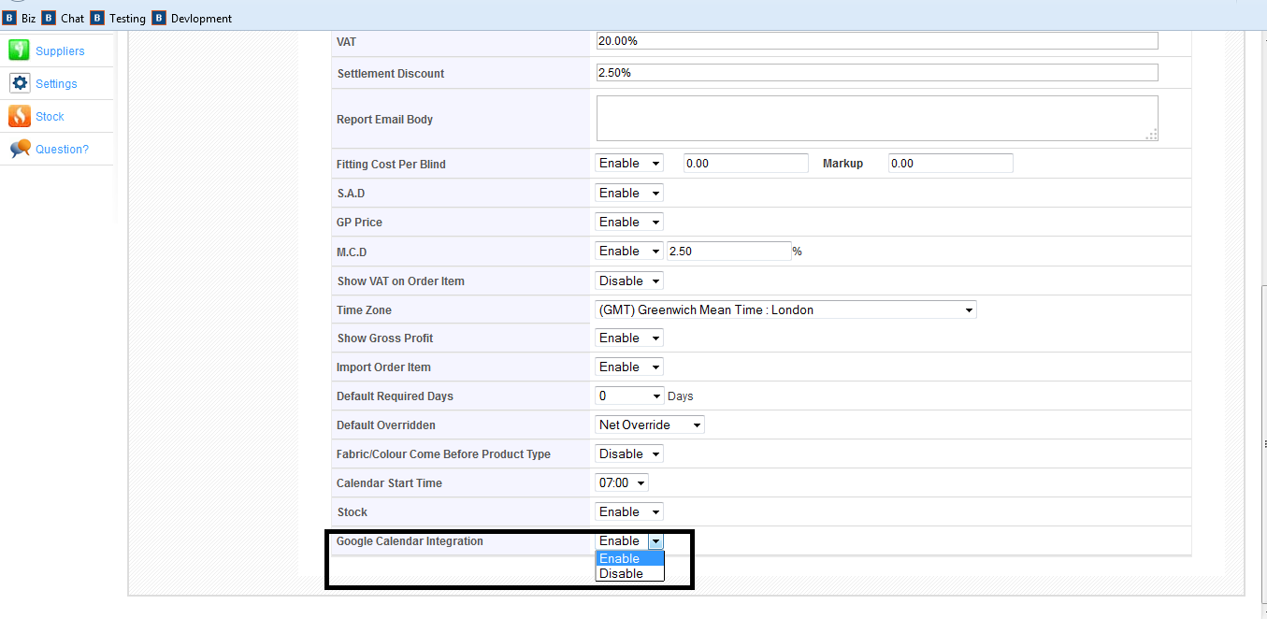
Step 2: Enable the” Google Calendar Integration” option
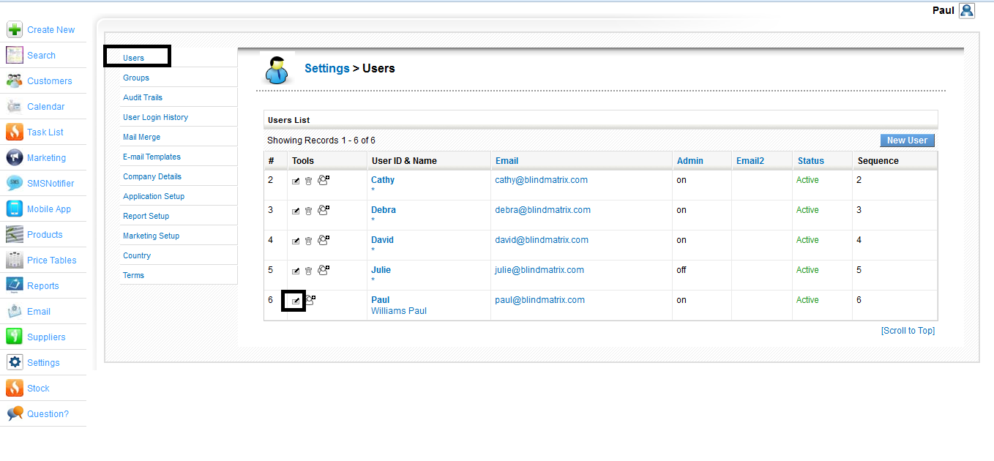
Step 3: Click on Users
Step 4: Edit your user by clicking this button

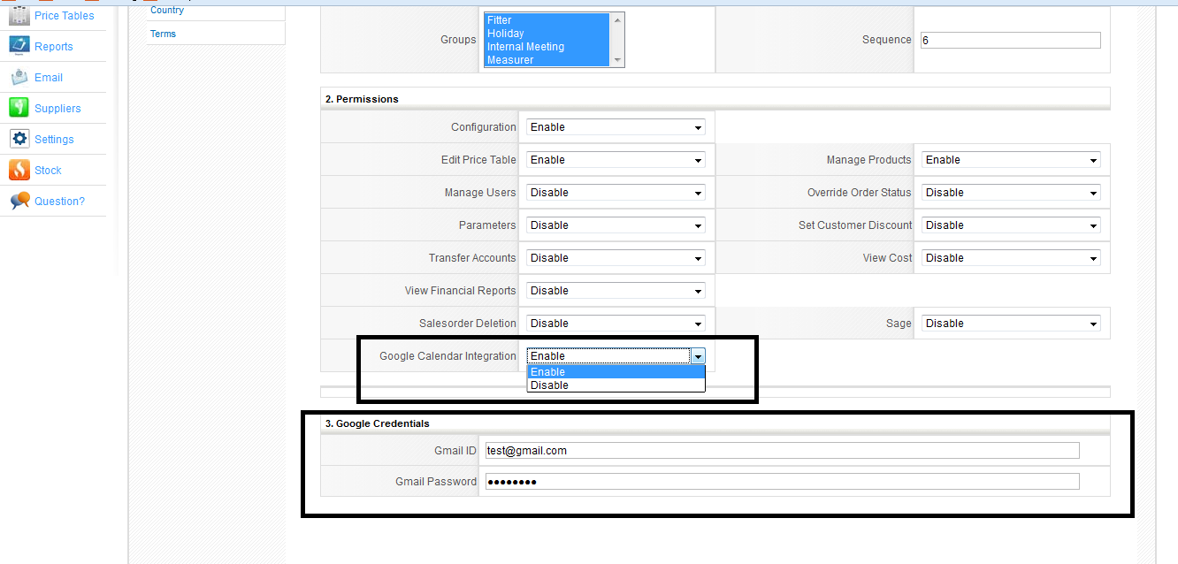
Step 5: Under Permission Enable the Google calendar integration.
Step 6: Enter your Gmail id and password and click on save.

I) synchronize appointments from BlindMatrix calendar to Google calendar:

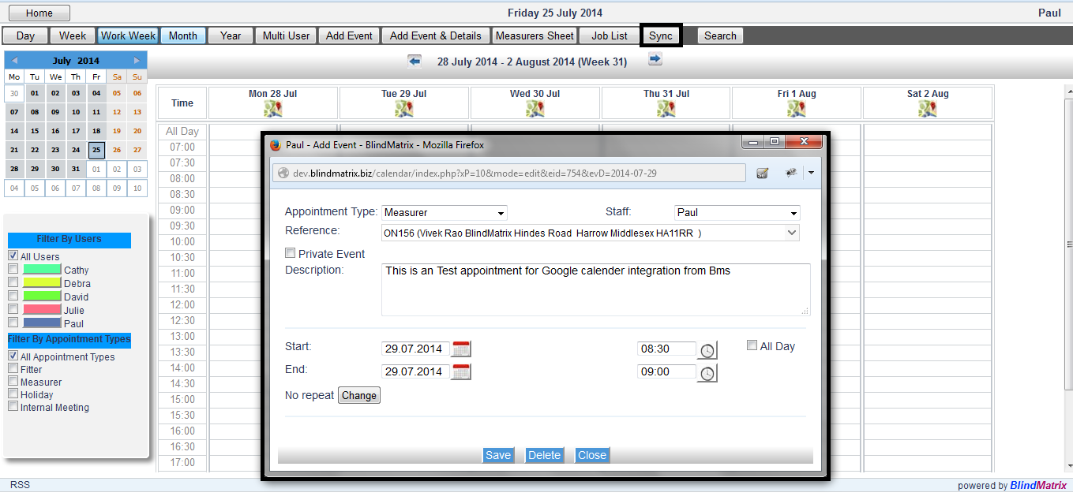
Step 7: Enter an appointment from BlindMatrix and click on save
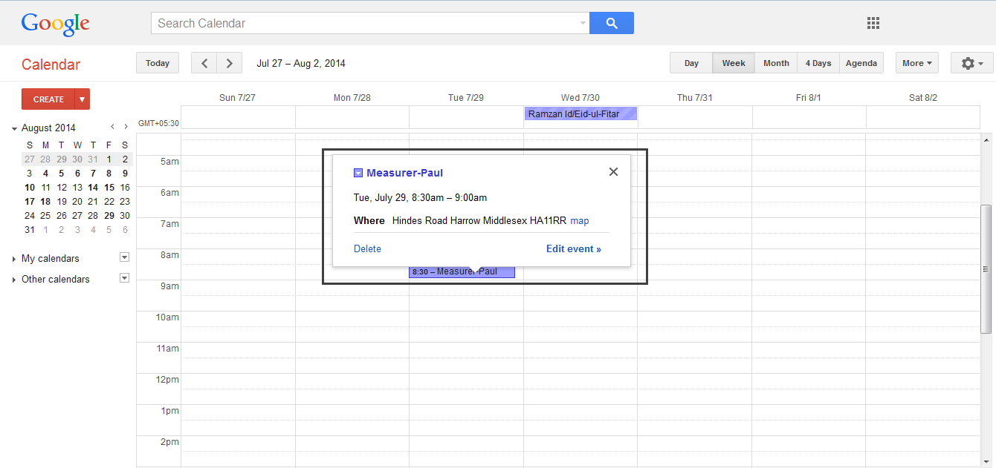
Step 8: Open up the Google calendar and then click on refresh by pressing ” F5” button in your keyboard and you'll see the appointments

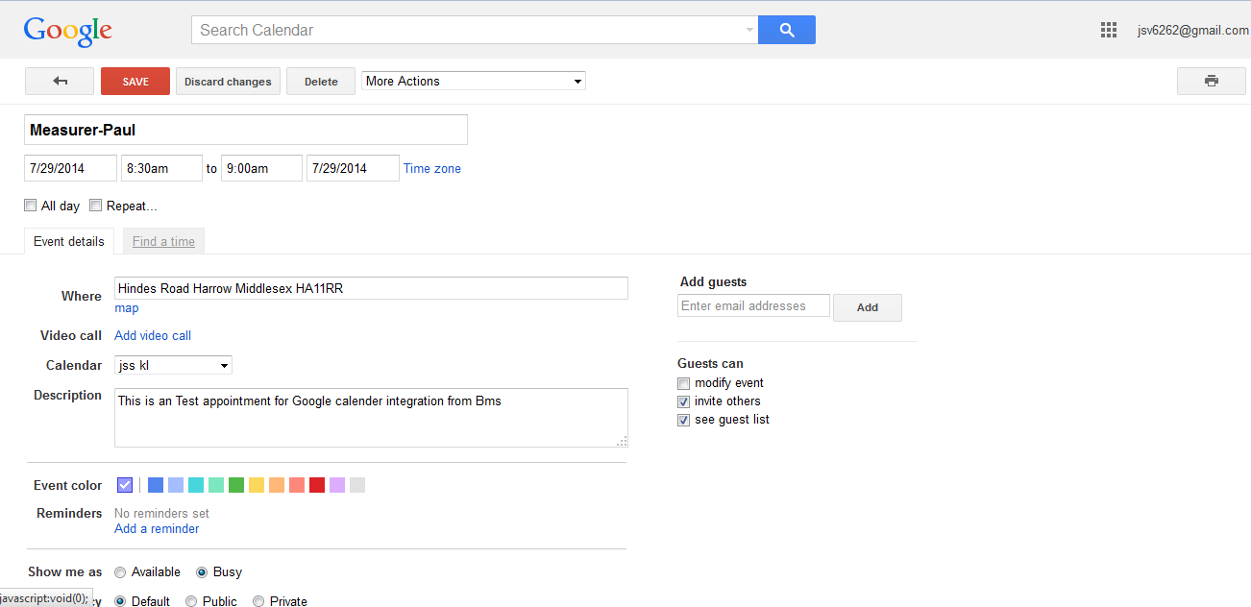
Step 9: Details of the appointment can be viewed by selecting edit event or double click on the appointment.

ii) Synchronizing Appointments from Google calendar to BlindMatrix Calendar:

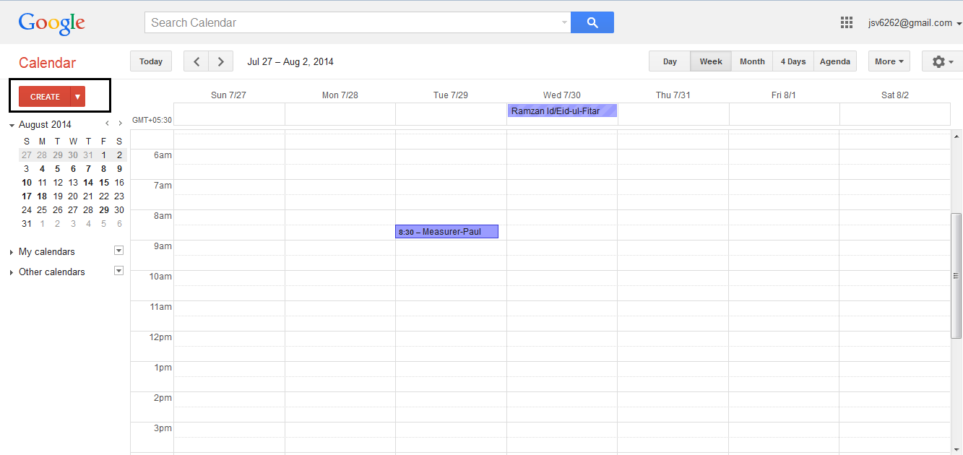
Step 10: Click on create button

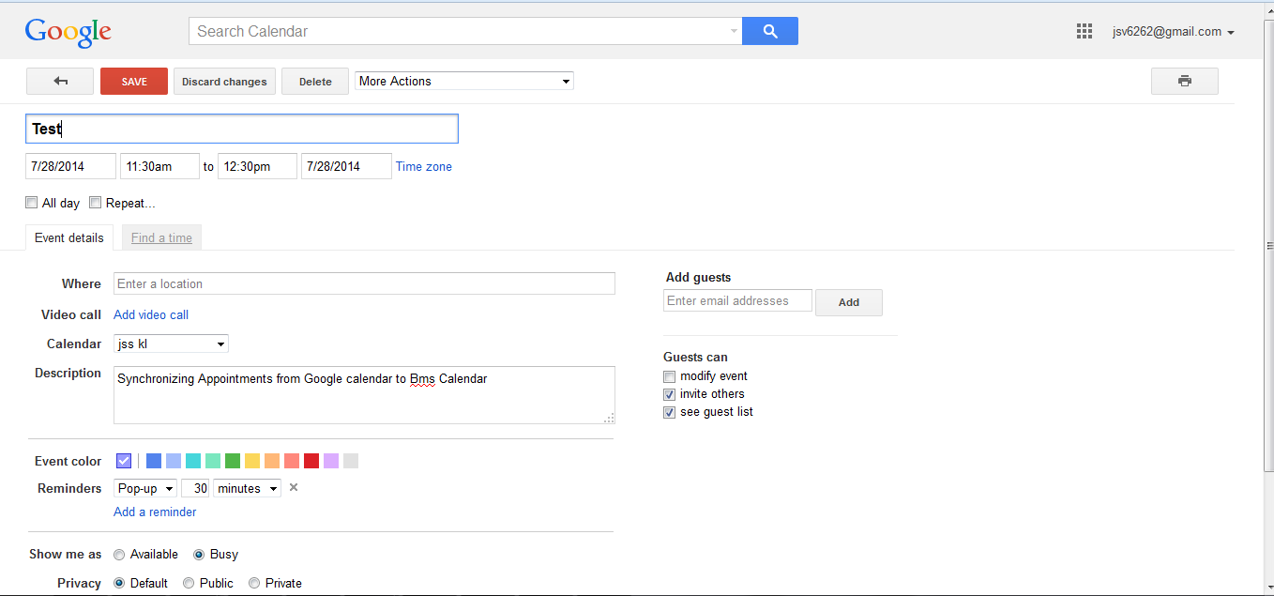
Step 11: Enter the “Title” “start and End date”, “Start and End time” and “Description” and click on save.

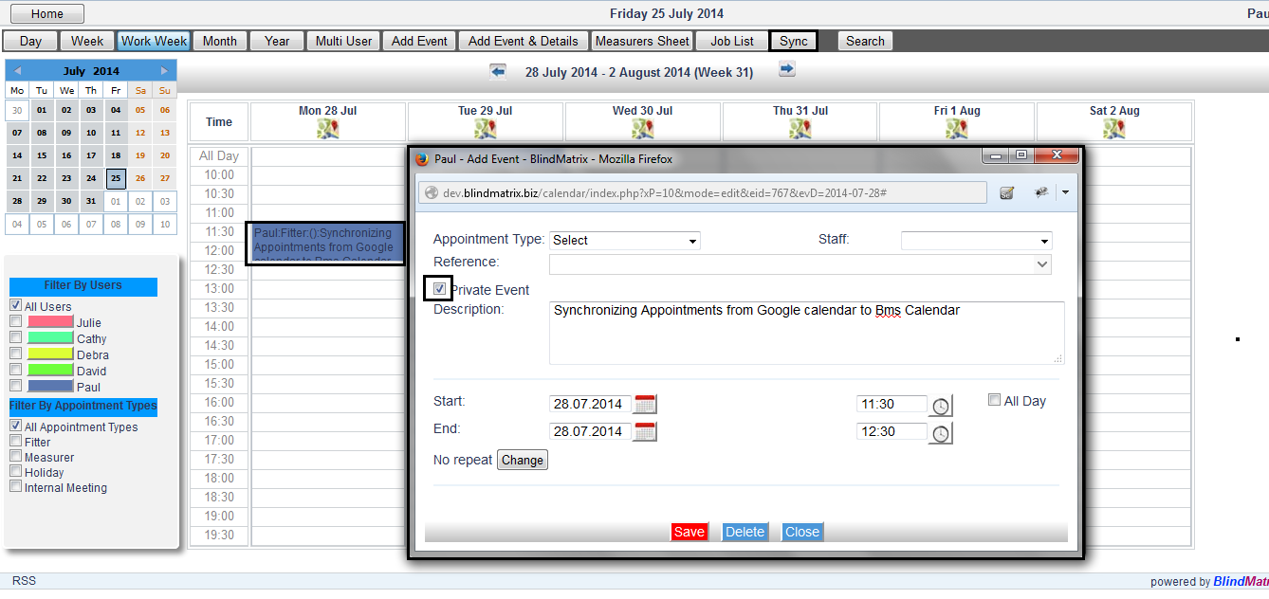
Step 13: Appointments will be displayed.
Step 12: Click on Sync button, once you have added the appointments in Google calendar.
Step 14: Double click on the appointment to view the details

Note: Appointments that has been entered via Google calendar will have “Title” “start and End date”, “Start and End time” and “Description” only and it is a private event.

