EDI Changes:
- When I add new Field by default it should show the Edi Name on that column and it should be disable on EDI.

- In Supplier->Order Sending Method by default show on the Drop Down as “Disable” on Transfer Method no need to show as select.
For Transfer Type also Remove Select option and set as Whole Order.

3) Database Name Text Column allow to enter the DB Name on Capital.

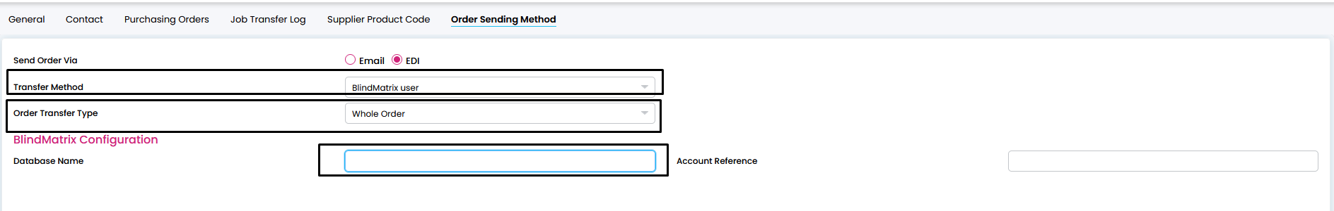

4)

