1.When I add a price band in the Price Table section, there is a UI issue with the price band display.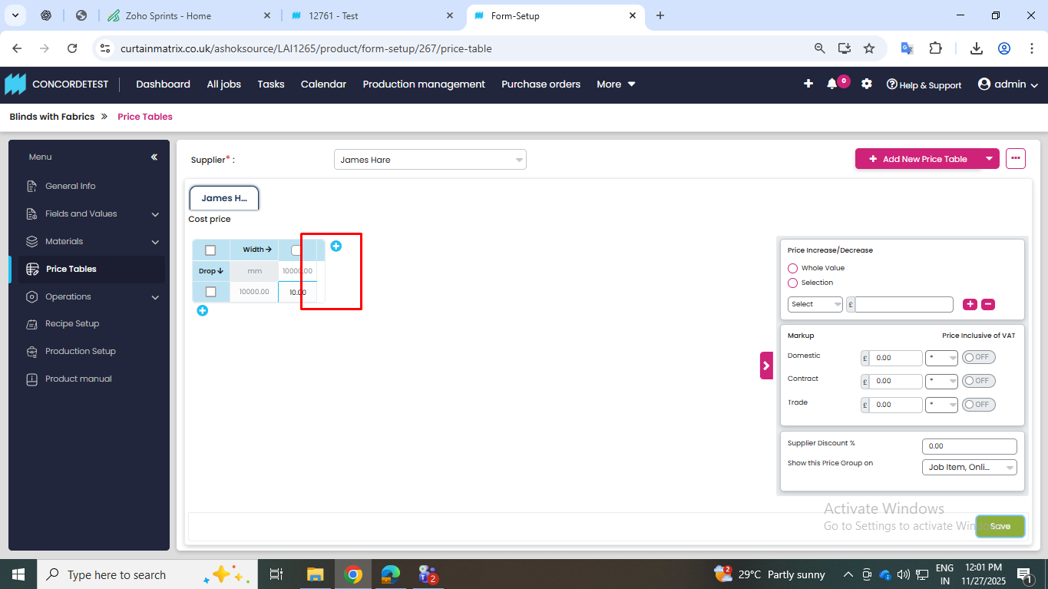
2. The fabric is not getting unlinked from Level 3, Level 4, and Level 5 (Blinds Fabrics Materials fields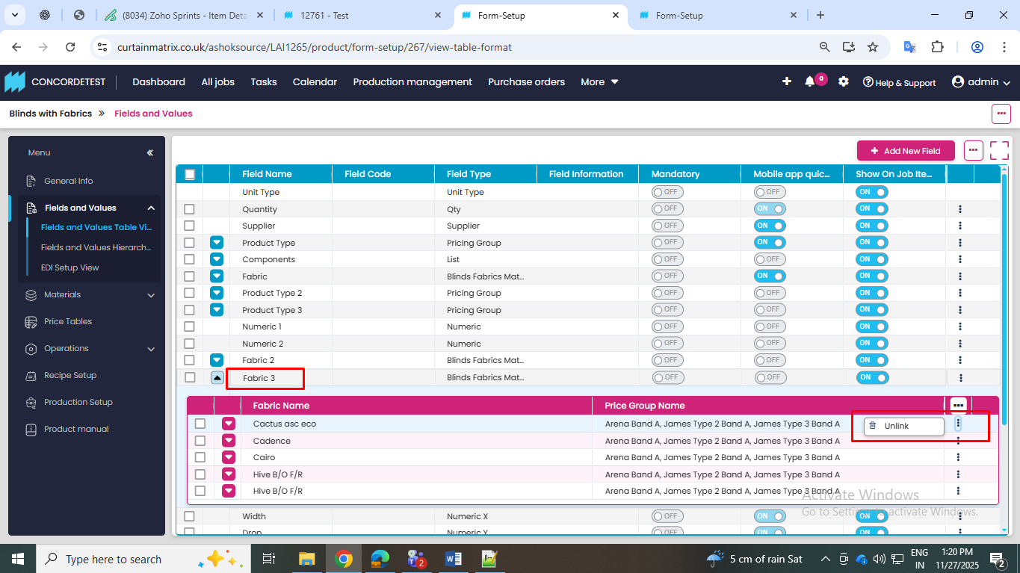
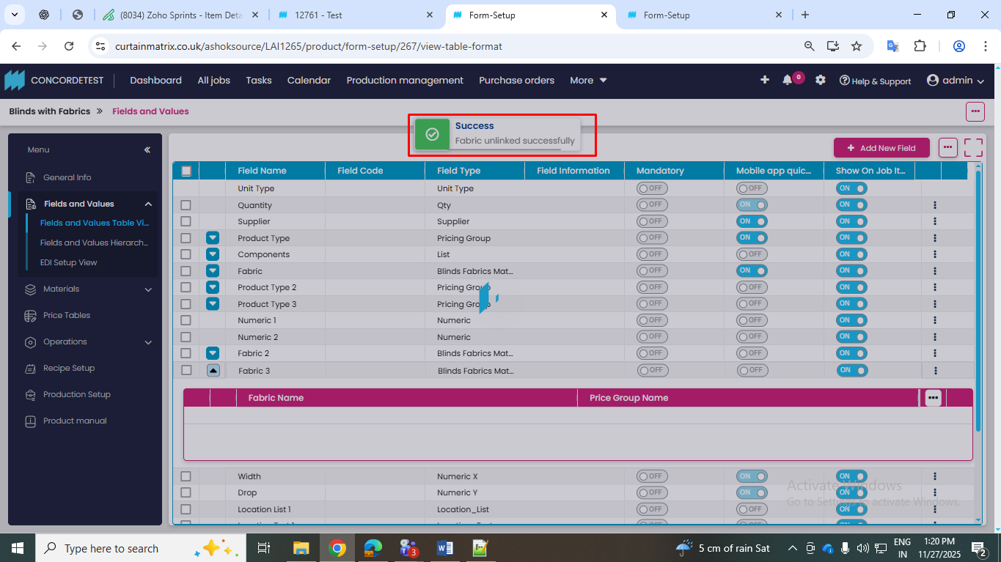
The popup shows ‘Fabric unlinked’, but the fabric is not actually unlinked.
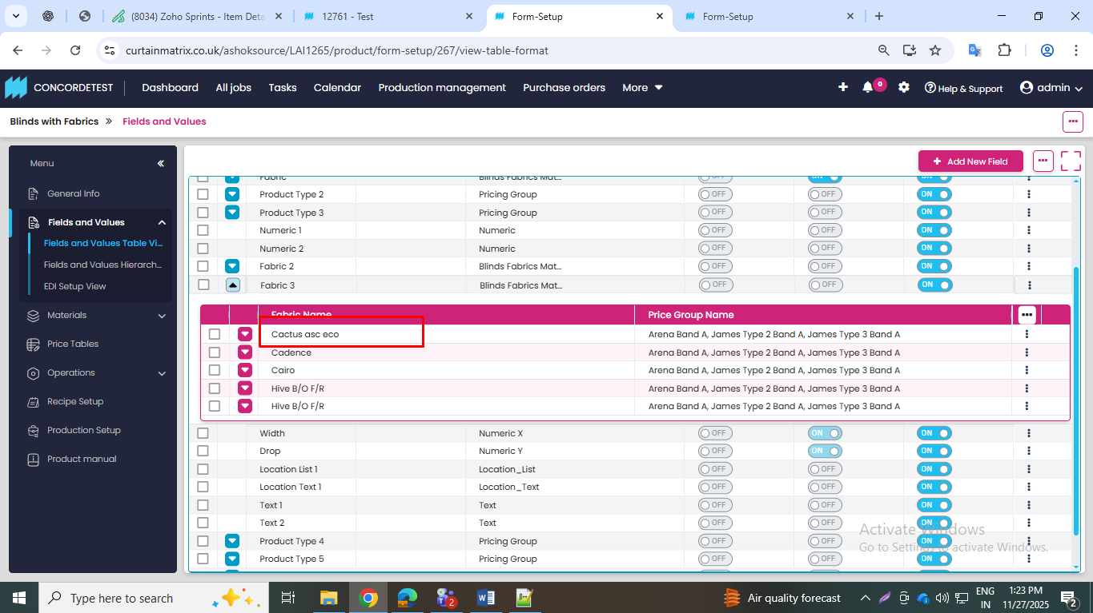

3. In the recipe setup, the product type is appearing multiple times.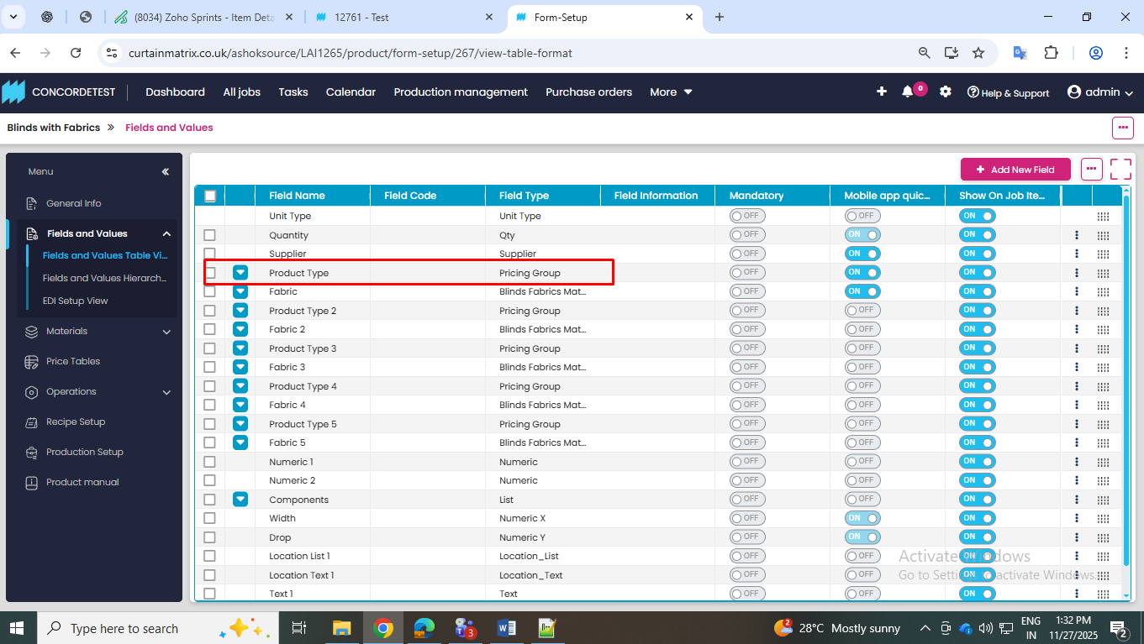
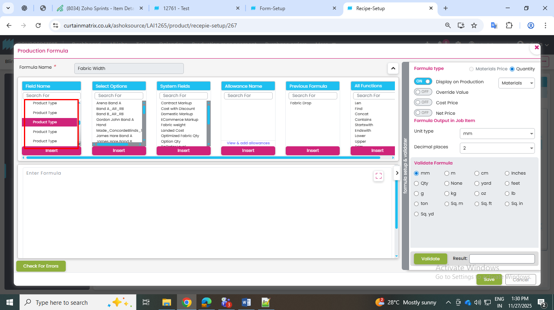

4. If I create fields in the Fields and Values Table View and then delete them, the deleted fields are still showing in the Recipe section.
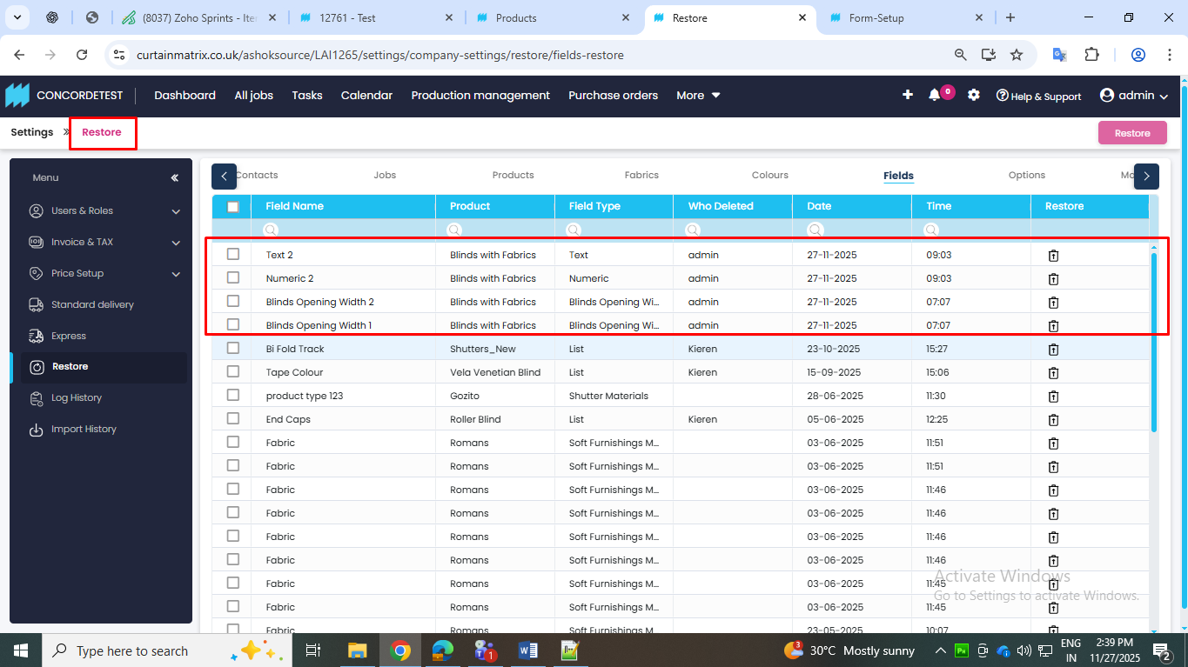
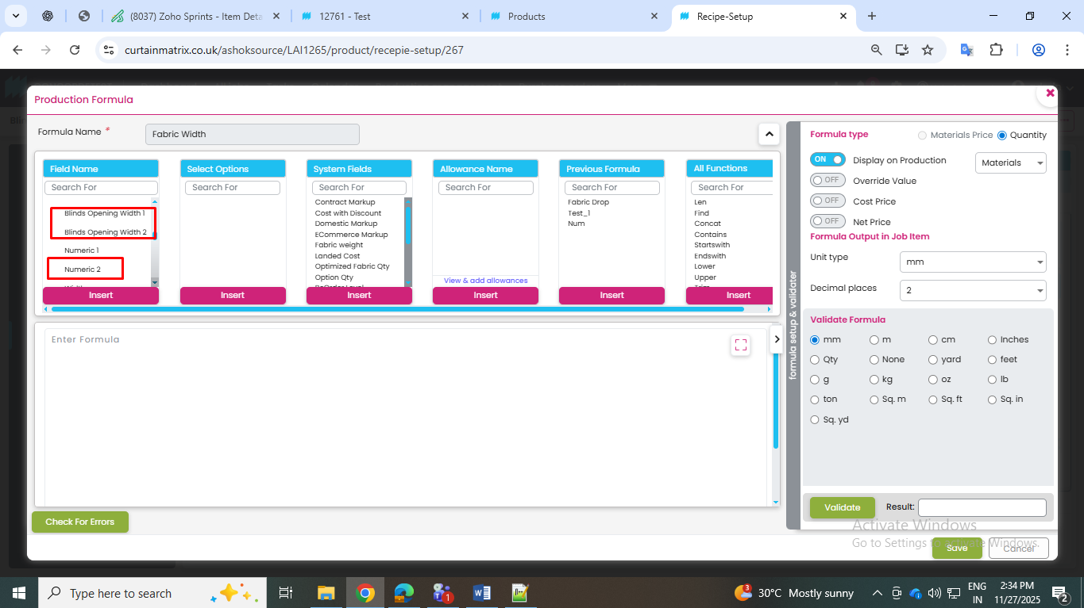
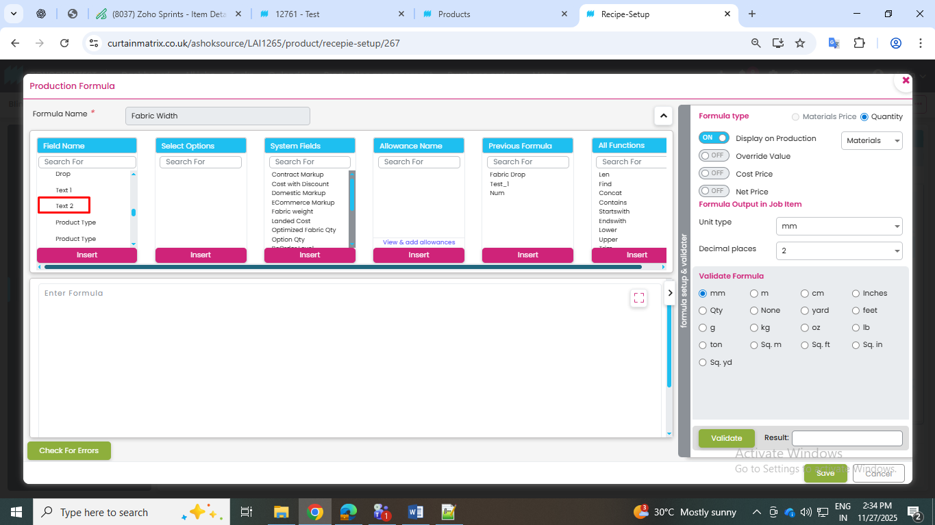

5. When I try to link an existing price band, the Select pricing group field should be displayed, but it is not showing.
